**Course Specialist Test 4 Year 12**

Student name: ________________ Teacher name: ________________

**Task type: Response**

**Time allowed for this task: ____40_______ mins**

**Number of questions: _____7______**

**Materials required:** Calculator with CAS capability (to be provided by the student)

Standard items: Pens (blue/black preferred), pencils (including coloured), sharpener, correction fluid/tape, eraser, ruler, highlighters

Special items: Drawing instruments, templates, notes on one unfolded sheet of   
A4 paper, and up to three calculators approved for use in the WACE examinations

**Marks available: _44_____ marks**

**Task weighting: _10___%**

**Formula sheet provided: Yes**

**Note: All part questions worth more than 2 marks require working to obtain full marks.**

Q1 (3 & 3 = 6 marks)

Solve the following.

1.  given that when .
2.  given that when .

Q2 (4 marks)

An iron has a temperature of  is left in a room, of temperature , to cool such that the temperature  at time  minutes is given by . After 15 mins the temperature of the iron is . Determine the time taken for the iron’s temperature to drop to .

Q3 (1, 5 & 2 = 8 marks)

The number  thousands, of bacteria cells living in a petri dish at time  hours is given by .

The initial number of cells was 2 thousand.

1. What is the limiting value of the number of cells as ?
2. Using calculus and partial fractions, show every step to express  in terms of .

Q3-cont

1. Determine the number of cells after 15 hours.

Q4 (3, 2 & 2 = 7 marks)

Consider the slope field 

1. Sketch this field on the axes below.

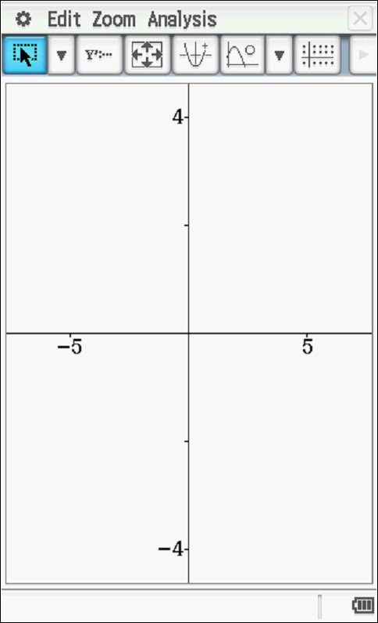

1. Draw the solution curve, axes above, that contains the point (1,1).
2. Determine the equation of the solution curve that contains (1,1).

Q5 (2, 2 & 3 = 7 marks)

Consider an object that is moving with Simple Harmonic Motion such that  with  in metres and seconds respectively. At ,  metres and is a rest.

1. Determine a rule for  in terms of .
2. Determine the exact speed when  metres.
3. Determine the percentage of the time, to one decimal place, that the object is less than 3 metres from the mean position, .

Q6 (4 marks)

Consider an object that is initially at the origin and at rest such that its acceleration is given by  where  equals the speed in at seconds . Determine the exact speed when its displacement from the origin is  metres.

Q7 (2, 3 & 3 = 8 marks)

A lolly company makes jelly beans where the mass of one jelly bean is normally distributed with a mean of 23.4 mg and a standard deviation of 3.2 mg. (Note: 1g=1000mg)

1. Determine the probability to two decimal places that the total mass of 85 jelly beans is more than two grams.
2. Given that the probability that the mean mass of a jelly bean differs from the population mean by more than 0.35 mg is 5%, determine , the number of jelly beans that need to be sampled.
3. On a particular day the operator of a machine that makes jelly beans is suspected of being faulty. A sample of 200 jelly beans had a sample standard deviation of 3.8 mg with a total mass of 5.4 grams. Present a mathematical argument to either support or to dismiss such a claim.